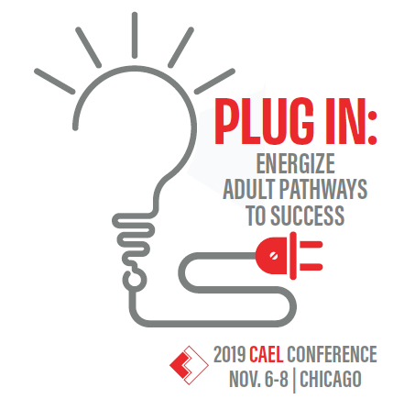

Dear [name],
I would like to attend the annual Council for Adult and Experiential Learning (CAEL) Conference Nov. 6-8, 2019 in Chicago, IL. The theme of the 2019 CAEL Conference is "Plug In: Energize Adult Pathways to Success."
With my attendance at CAEL’s conference, I can choose from numerous sessions spanning a wide variety of topics and special interest areas, including outreach and marketing to adults, prior learning assessment, military-connected students, stackable and micro credentials, accelerated programs, employer partnerships, and many more. Additionally, I can attend [insert speaker]’s keynote presentation to learn [insert session highlights] and [insert selection(s)] workshop(s) to enhance both my work and contribute to the work of [insert institution] toward improving learning opportunities for adults. CAEL’s conference provides opportunities to attend several pre-conference workshops, including [your selections] that provide valuable information and resources that will provide strategies for improving our adult learner initiatives.
Attending the 2019 CAEL Conference is an investment in professional development that will enable me to learn, explore, and discuss new theories, research and tools that can help us reimagine and create lifelong pathways that integrate learning and work. I plan to make new connections, collect innovative resources and information, and share the knowledge I gained from this conference with colleagues from various handouts, presentations and supporting materials.
I would like to take advantage of special pricing. CAEL offers discounted conference rates for early registrations. You can learn more about the CAEL conference at https://www.cael.org/conference.
Thank you for reviewing my request. I look forward to attending and representing [insert institution]. Please let me know if there is any additional information I can provide.
Sincerely,
[insert your name]

